Photography and Filming Policy

The use of photography is really important to record the successes and achievements of children, young people and adults at risk in their lives and activities. However, it is vital to remember that photography can be used and distributed inappropriately including on the Internet.

It is therefore important to be clear about:
- explaining to parents and carers why caution is necessary in our facilities
- the purpose of photos e.g. parent’s and carer’s own record, media and publicity etc
- the content required when using a professional photographer
- informing parents/carers and seeking their consent for any publication or media use
- publishing only limited details alongside individual’s photos in newspapers etc
- taking photographs openly and away from changing areas
- the suitability of clothing e.g. swimsuits
- any group photos being taken only during the activity or on the premises
- all those taking photos signing a registration form, which includes the reason, use and storage of all photographs and films
The above guidance applies to any photographic and filming equipment including camera phones, digital or video cameras, which and who’s equipment is used should also be recorded on the registration form.

Consent is required for all forms of media outlet at our facilities and all sections of the consent form must be agreed to. If there is one area which is not agreed to, any consent is nullified to prevent unconsented distribution. (see the form below)

Staff may take photos using their camera phone in their area to allow photos that capture special moments. These will be immediately forwarded to the Gympanzees Phone and deleted off personal devices. These are then securely stored by Gympanzees and deleted off the Gympanzees phone.

At our facilities photography and filming is not allowed so staff supervising the activity rooms must be watchful for the use of phone cameras by parents using the facility. The particular concern at Gympanzees is the inadvertent dissemination into digital outlets of traceable information about the location of children in the background that might give rise to safeguarding concerns. Photos may be taken with the explicit permission from staff on site provided there is no one else in the photo.

Written consent will be obtained from all parents/carers regarding photography and filming. All those that withhold consent will be clearly identifiable to alert the supervising staff of the issue.

For the lending Library, parents can send us photos of their children using the equipment but must fill in a consent form before sending photos or videos digitally. They are then stored securely by Gympanzees.

Gympanzees will employ professional photographers from time to time for promotion of our activities. They will comply with the following:
- All those taking photos/film will sign a registration form.
- They will be accompanied by a member of staff at all times.
- They will obtain parental consent for all those (subject or background) in the photographs.
- They will obtain parental consent to publish the photos widely.
- They will take all photos openly and away from changing areas.

Gypmanzees Consent Form for parents to complete for permission to be photographed is below.

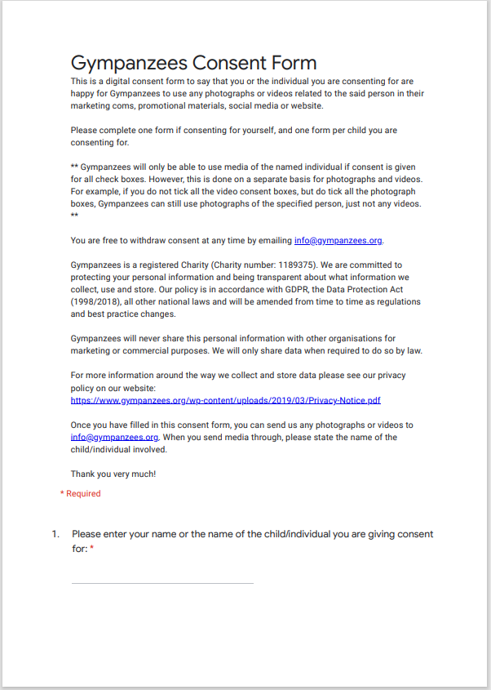
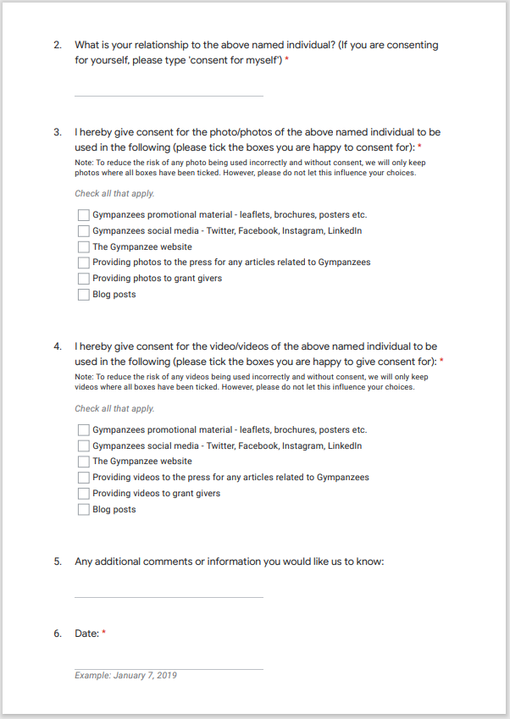

E. S. Scholey 18/02/2021
Review date 17/02/2022

